Pizza Ordering Java Application

Weslyn Wagner (zfs119)
EE 5453 – Engineering Programming II
University of Texas at San Antonio, Department of Electrical Engineering
San Antonio, Texas
Weslyn.wagner@my.utsa.edu

Abstract—write an abstract of few lines
Keywords—java; GUI; graphics; PizzaOrder; input file;

Introduction
This java application is designed to allow a user to custom order a pizza from a selection of pizza bases, namely, cheese, size, and crust through a graphical user interface. It is designed in consideration of ease of use such that the aforementioned bases are chosen from sets of radio button groups that allow a single selection of each type. In addition to those bases, there is also a collection of available toppings from which the user can choose. These toppings are stored after being read from a file of string items. These toppings are displayed in the GUI and the user is allowed to add each desired topping to the pizza one at a time and only once. When the selection is complete, the user can opt to have the order picked up or delivered. Both options require a name for the order, but the delivery option also prompts the user to enter an address. The final order details are then displayed in the GUI and the program is complete. To implement this functionality, three classes are used—a ClassProject class holds the main function which reads the file and calls the Menu GUI class; a PizzaOrder class to construct the pizzaOrder object and its attributes along with necessary member methods; and finally a Menu class that contains all relevant graphical elements and appropriate calls to the PizzaOrder class. The specifications of each of these are discussed in the following section.

Specifications
The specifications for the preceding classes are displayed in table formats below. These include all pertinent constructors and member methods. For brevity, the specifications for each graphical element are not included here but can be examined in the included program code.

Constructors and Default Variables
+PizzaOrder(String size)
+cheese = "Mozzarrella";
+size = "Medium";
+type = "Regular";
+toppings = null;
+PizzaOrder(String size, String type)
+cheese = "Mozzarrella";
+this.size = size;
+this.type = type;
+toppings = null;
+PizzaOrder(String size, String type, String cheese)
+this.cheese = cheese;
+this.size = size;
+this.type = type;
+toppings = null;
+PizzaOrder(String size, String type, String cheese, ArrayList<String> toppings)
+this.cheese = cheese;
+this.size = size;
+this.type = type;
+this.toppings = toppings;

Member Methods
+AddTopping(String topping) | Return void
+CalculateCost(PizzaOrder p) | Return BigDecimal
+Order(PizzaOrder p) | Return String
+Pickup() | Return String
+Deliver(String name, String address) | Return String

Member Method Functionality
- AddTopping()
This method takes one String input, topping, and tests whether or not that topping is in the list of available toppings. If not, then an error message is thrown to tell the user that the particular topping is not available. If it is available, then the logic tests whether or not that topping is already stored in the ArrayList topping variable. If it is, then an error message is thrown to tell the user that the topping is already contained in the added toppings ArrayList. If not, then that input topping is finally added to the toppings ArrayList.
- CalculateCost()
This method calculates the cost of the order as the method name entails. It takes one input, a PizzaOrder object, and returns the cost of the pizza as a BigDecimal so that the precision can be controlled to specifically two decimal places. The method tests the values of the input PizzaOrder object and then tallies the cost as a Double before being converted to a BigDecimal in the return statement.
- Order()
This method takes one input, a PizzaOrder object, and returns a String message to the user confirming that the order has been placed and displays the cost. Included in this message is a call to the CalculateCost() method, which upon return is converted to a String with the .toString() method.
- Pickup()
This method takes no inputs and simply returns a String message letting the user know that the order will be ready for pickup in 20 minutes.
- Deliver()
This method takes two inputs, String name and String address, and returns a confirmation message to the user that the order will be delivered with that name to that address.

Class Description

Detailed Functionality
The application is strategically devised into four parts: the main class, an object functionality class, a graphical element class, and a referential text file. Each of these is necessary in terms of both modularity and robustness of the program. The detailed functionality of each of these pieces is explained below in the order as it executes in the program.
The main class is the first block of executed code in the program. Its function is simple—first, it reads the included text file that contains several lines of string items referred to as toppings and stores each of those items in an ArrayList. This includes some IO error checking to preserve data integrity. Second, the main function instantiates the Menu class and sets the user interface visible so that the user can interact with the program. The default Menu is shown below.
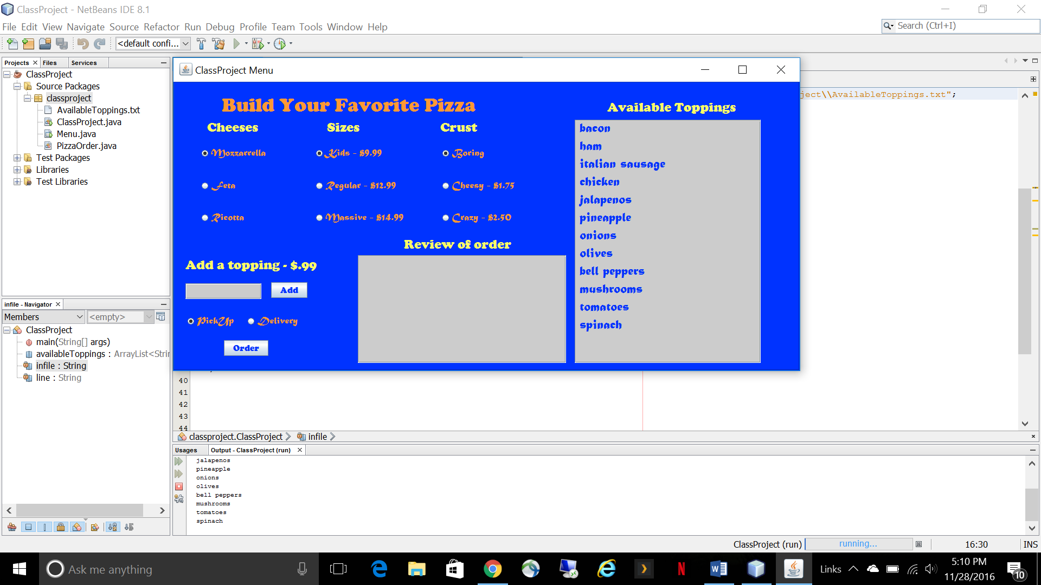

Once the Menu class is instantiated, it calls a method of its own called initComponents() which initializes and sets all of the graphical elements and their custom configurations for the GUI. For increased efficiency, NetBeans self generates this block of code after the programmer drags and drops elements and sets their respective properties in the enhanced design IDE. This saves time for the programmer and limits the chance of human error throughout application development. For this project, this technique is used where applicable. After initialization, some custom configuration is needed to group radio buttons and to set default selections. Button Groups are used for this purpose, which simply require individual Radio Buttons to be added to them. Here, there are four such sets—cheese, size, crust, and pickup/delivery. The first three each have three Radio Button options, while the pickup/delivery group only includes those two. These groups are included to force the user to be allowed to only select a single option for each group. By default, Radio Buttons are not selected, so the base choices of “Mozarrella”, “Kids”, “Boring”, and “PickUp” are set to be the default selections for this application.
There are two TextAreas included in the application; one for displaying the available toppings, and one for reviewing the order. The first functions by looping through the previously defined ArrayList for available toppings and appending them to the TextArea line by line. Options for making this text un-editable are enabled and word wrapping is used for aesthetical purposes. The same is done for the order review text area, with the exception of its textual contents, which is to follow.
There are two actionable events triggered by the user. The first is when the user adds a topping to the TextField clicks the “Add” button. When this happens, the AddTopping method is called from the PizzaOrder class and provides some error checking that is described in the feature set section. Assuming there are no errors, the desired topping gets added to the ArrayList of toppings for the order, the TextField gets cleared, and the order review TextArea is populated with a summary of the user’s selection. This can happen as many times as there are available toppings or not at all; this is the user’s choice.
The second actionable event triggered by the user is for executing the order. This event is designed for execution after all the desired radio buttons are selected and all desired toppings have been added. This assumption is left to the user’s intuition, as it does not make sense to submit the order before each choice has been made. If this is the case, however, the order will execute based upon the default selections and the toppings that have been added up until the point of submission. At this point, a text box pops up and prompts the user to enter a name for the order, which is later passed to the order review TextArea. If the “PickUp” option is selected, then the user is only prompted for a name. If the “Delivery” option is selected, the user is likewise prompted to enter a name and then enter an appropriate address for delivery.
After the user is finished entering the pertinent information, the input parameters are passed into the instantiation of a new PizzaOrder object. This allows for various methods to be called to return back specific data types containing information that is used for display to the user. Calls to each of the getters are

made to return the PizzaOrder attributes, and the Order method is then called. This returns a simple string message letting the user know that the order has been placed, but it also makes a call to the CalculateCost method, which calculates the total cost of the order. It does this by passing in a PizzaOrder object and matching each of its attributes to a price with if/else statements. These prices are hard coded, but could easily be changed to reference variables if desired. The size of the topping ArrayList conveniently returns the number of elements, so this integer is multiplied by 0.99 to represent the total cost of the added toppings. After these if/else statements are complete, the total cost can be returned; in order to gain precision control, the return type for the CalculateCost method is set to be a BigDecimal, with the scale set to two decimal places and any trailing digits rounded up.
Finally, if the “PickUp” option is selected, then the PickUp method is called and returns a string message to the user in the review order TextArea that tells the user that the pizza will be ready for pickup in a short time. If the “Delivery” option is selected, then the Delivery method is called and returns a string message to the user in the review order TextArea that tells the user that the pizza will be delivered to the name given at the address given. At this point, the program is finished executing.

Feature Set
- Graphics
The layout of the graphical user interface is designed to appease the user and to be as intuitive as possible. Radio Buttons are utilized to limit group selections to a single element, TextAreas are utilized to display information that can potentially vary, and buttons are utilized to trigger all events. The color scheme is chosen from sets of complimentary colors from [] to make the interface appealing. Specifically, the color scheme is as follows: [0,51,255] for blue, [255,153,51] for orange, [255,255,102] for yellow, and [204,204,204] for grey. Fonts are either “Cooper Black, Plain” or “Matura MT Script Capitals.”
- Input Dialogs
These are utilized to gather input from the user where necessary. As described earlier, the user has to enter a name for the order—this is accomplished with the use of a JOptionPane and showInputDialog method with a few custom
parameters. The same is built for the entered address for delivery.
- Error Checking

Error Checking

Conclusions
Describe in detail the improvements and modifications you made to the original design. Justify the changes.
Describe in detail the problems encountered and how they were resolved.

References
The template will number citations consecutively within brackets [1]. The sentence punctuation follows the bracket [2]. Refer simply to the reference number, as in [3]—do not use “Ref. [3]” or “reference [3]” except at the beginning of a sentence: “Reference [3] was the first ...”

- G. Eason, B. Noble, and I. N. Sneddon, “On certain integrals of Lipschitz-Hankel type involving products of Bessel functions,” Phil. Trans. Roy. Soc. London, vol. A247, pp. 529–551, April 1955. (references)
- J. Clerk Maxwell, A Treatise on Electricity and Magnetism, 3rd ed., vol. 2. Oxford: Clarendon, 1892, pp.68–73.
- I. S. Jacobs and C. P. Bean, “Fine particles, thin films and exchange anisotropy,” in Magnetism, vol. III, G. T. Rado and H. Suhl, Eds. New York: Academic, 1963, pp. 271–350.
- K. Elissa, “Title of paper if known,” unpublished.

Appendix I – Program code
Paste your code as single space font size 7 or smaller. Misalignment in code when pasted is understood.

Marks for the report & presentation will be as follows:

Working code with successful demonstration 20%
Effort in the design of the applet/class 20%
Extent of use of graphics and textiles 10%
Clarity and descriptions in section III of this report 20%
Clarity and descriptions in section IV of this report 20%
Use of comments, tabbing, formatting and readability of the code 10%

When the user clicks the “Add” button, the AddToppings method from the PizzaOrder class is called. In order to prevent the user from attempting to add a topping that is not available or duplicating a topping, the code first checks to see if the entered value is contained in the availableToppings ArrayList. If so, then the logic proceeds. If not, then a warning message pops up to tell the user that the entry is not valid. If the entry is valid, the code checks to see if the user has already added that particular topping by checking the elements of the toppings ArrayList. If so, then an error message pops us to tell the user that the particular topping has already been added

